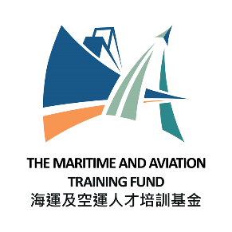
Maritime and Aviation Training Fund
Maritime and Aviation Internship Scheme (MAIS) (Aviation)

Registration Form for Internship Positions (2026)

Please submit this form by -
By Fax : 2523 0030 or
By E-mail : internship_matf@tlb.gov.hk
To: Maritime and Aviation Training Fund
Transport and Logistics Bureau

Part A: Company Information

Company Name
Contact Person  (e.g. Human Resource Manager) | Name : _______________________________________________________________________________  Post title : ____________________________________________________  Tel no : _______________________________________________________________________________  Email address: _________________________________________________________________________
Company Address

Business Registration Number

A brief introduction of the company and descriptions of the business activities that are relevant to the aviation industry

Objective(s) of Internship Experience to be offered

Maximum Number of Intern Position(s) to be Offered*
*Companies are free to select suitable student(s) as intern(s) and have no obligation to fill all registered internship position(s). However, companies are encouraged to fill all the registered positions as far as possible.

Part B: Information for Advertising the Registered Internship Positions of MAIS (Aviation)

Company name and company website | No. of intern places | Main job duties  (Please specify the aviation-related job duties) | Internship period  (minimum 4 weeks, i.e. 28 days)  e.g. 1/6/2026 to 31/7/2026 | Monthly Honorarium  per Intern  (HK$) | Specific Requirements  (if any)  e.g. area of study /  skill / language | Application Deadline  (a specific date or open until filled) | Application Method

Part C: Declaration

I have read, have understood, and undertake to comply with the following clauses:
- the Government reserves the right to disqualify this registration on the grounds that the participating company has engaged, is engaging, or is reasonably believed to have engaged or be engaging in acts or activities that are likely to cause or constitute the occurrence of offences endangering national security or otherwise the exclusion of the participating company from future registrations is necessary in the interest of national security, or is necessary to protect the public interest of Hong Kong, public morals, public order or public safety;
- even after the registration is approved, the Government may immediately withdraw or cancel the relevant approval, and the participating company has to repay to the Government all the monies received in connection with the registration and the Government reserves the right to recover by civil action and the participating company may be liable to prosecution, upon the occurrence of any of the following events:
- the participating company has engaged or is engaging in acts or activities that are likely to constitute or cause the occurrence of offences endangering national security or which would otherwise be contrary to the interest of national security;
- the continued disbursement to the participating company is contrary to the interest of national security; or
- the Government reasonably believes that any of the events mentioned above is about to occur.

Official Company Stamp

Signature of Authorised Person :
(For and on behalf of the company)
Name :
Position :
Telephone No. :
Email :
Date :

